Assignment-5

Task 1: In this task I have downloaded the data file and divided the file into intput.txt and output.txt files based on the criteria, i.e., pattern in a file input.txt and number 0-9 as 1000000000-0000000001 in output.txt, for this I have written an python code to separate the data file into separate text files for neural network training.

Task 2: To train pattern in neural network, In MATLAB input.txt and output.txt are given as Input data and Target data. When 10, 100, 500 hidden neurons are trained the outputs are as follows.

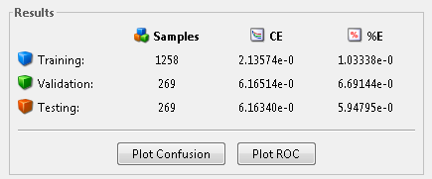Hidden Neurons -10:

Accuracy:

Training: 98.96662

Validation: 93.30856

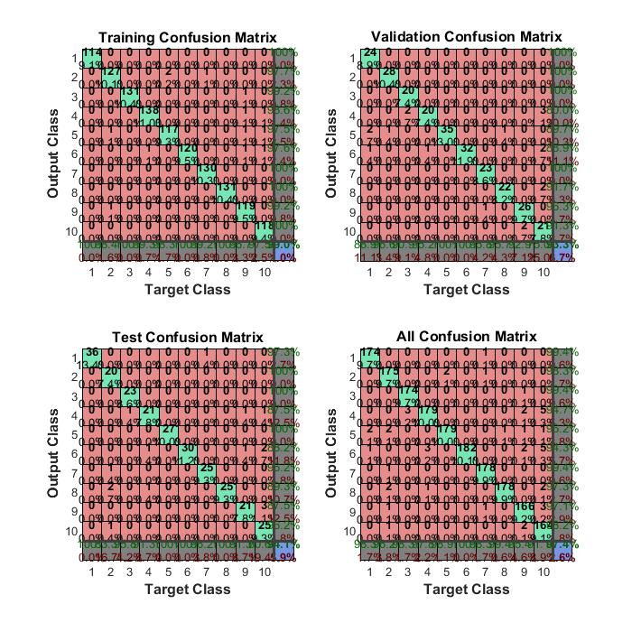Testing: 94.05205

Hiddeen Neurons :100

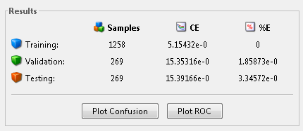

Accuracy:

Training: 0

Validation: 98.14127

Testing: 96.65428

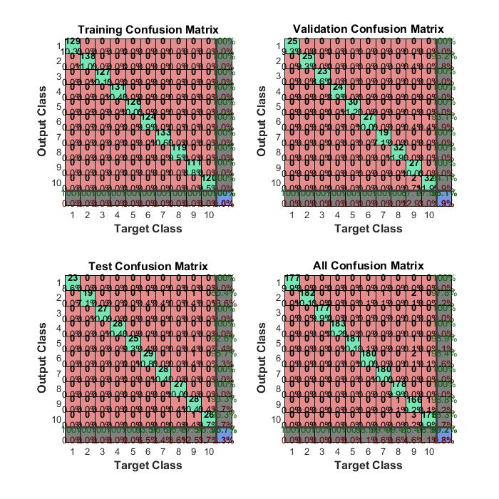

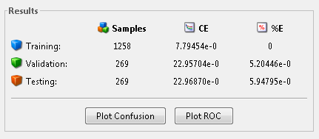Hidden Neurons -500

Accuracy:

Training: 0

Validation: 94.79554

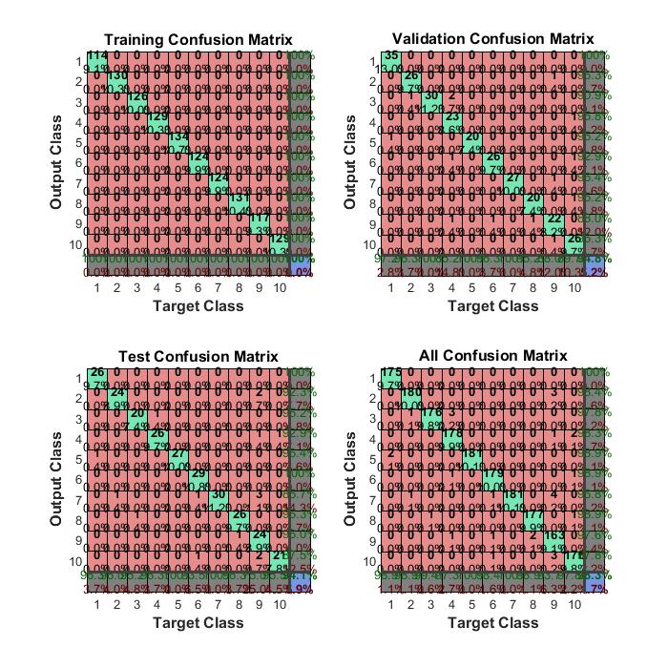Testing: 94.05205

Analysis: As the Hidden Neurons are trained the error rate for the 10 hidden neurons is more when compared to 100 hidden neurons but when the hidden neurons are increased the error rate increases, so the analytics says accuracy increases for 100 neurons but as the hidden neurons increases the accuracy decreases.